**Location of Files in Android Studio Project:**

AndroidManifest.xml: Project>app>src>main

MainAcitivity.java: Project>app>src>main>java>com>divyanshusharma>demoapp

activity_main.xml: project>app>src>ain>res>layout

**Defining New Functions:**

Use standard Java style function definitions

Use the suggestions so that the corresponding header files get imported automatically

Define the new functions in the MainActivity.java file inside the **public class** MainActivity and before the @override.

Always have the “Log” as the first statement in the function block to add the fact that the function worked in the Studio logs. Eg: Log.*i*(**"Info"**,**"Button was Pressed!"**);

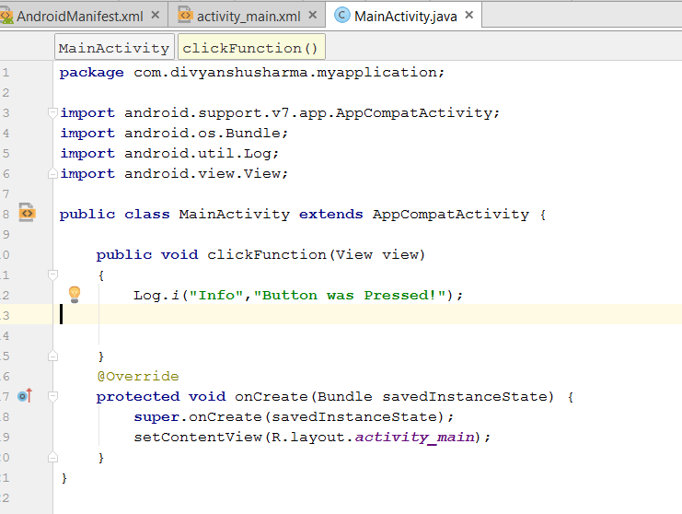

**Taking Input from user:**

**public class** MainActivity **extends** AppCompatActivity {  
  
 **public void** buttonClicked(View view)  
 {  
 EditText emailAddress=(EditText) findViewById(R.id.***emailAddress***);  
 EditText password=(EditText) findViewById(R.id.***Password***);  
  
 Log.*i*(**"User Info: "**,emailAddress.getText().toString()+**" and "**+ password.getText().toString());  
 }  
 @Override  
 **protected void** onCreate(Bundle savedInstanceState) {  
 **super**.onCreate(savedInstanceState);  
 setContentView(R.layout.***activity_main***);  
 }  
}

Use a correct widget such as EditText.

Use the corresponding class to take the input

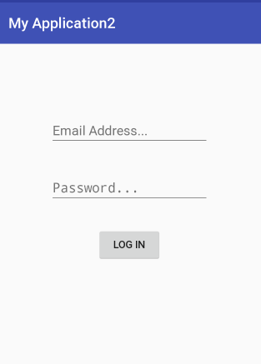

**eg:**

**Displaying a small Pop-up or TOAST!**

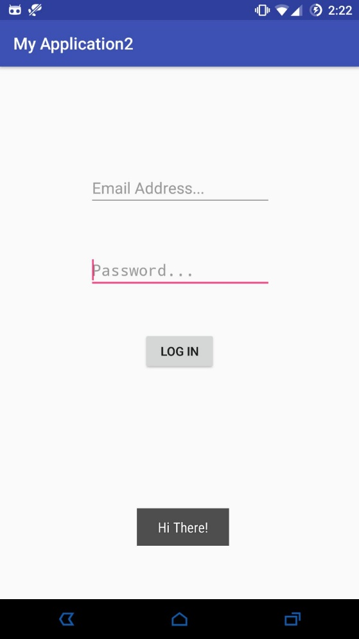Inside the Function where you want toast to pop-up type:



Toast.makeText(<context>,”<message>”,<Toast.LENGTH_LONG or Toast.LENGTH_SHORT>).show();

Context: the screen where you want it to appear

message: displayed message

Length_short or length_long: how long it should display

eg:

**public void** buttonClicked(View view)  
{  
 Toast.*makeText*(MainActivity.**this**,**"Hi There!"**,Toast.***LENGTH_LONG***).show(); }

Valid Conversions

Miles-km(*1.60934),m(*1609.34)

Feet-km(*0.0003048),m (*0.3048),cm(*30.48)

Inches-km(*2.54e-5),m(*0.0254),cm(*2.54)

mph-kph (*1.60934)

F-C (9/5*value +32)

Pounds-kg(*0.453592),g(*453.592)

Stones-kg(*6.35029),g(*6350.29)

Oz-kg(*0.0283495),g(*28.3495)

fl oz- litres(*0.0295735)

Gallons-litres(*3.78541)

<**item**>Miles</**item**>  
 <**item**>Feet</**item**>  
 <**item**>Inches</**item**>  
 <**item**>mph</**item**>  
 <**item**>Fahrenheit</**item**>  
 <**item**>Pounds</**item**>  
 <**item**>Stones</**item**>  
 <**item**>Ounces(Oz)</**item**>  
 <**item**>fl. Oz</**item**>  
 <**item**>gallons</**item**>  
</**string-array**>  
  
<**string-array name="Metric_Units"**>  
  
 <**item**>Km</**item**>  
 <**item**>Meters</**item**>  
 <**item**>cm</**item**>  
 <**item**>kph</**item**>  
 <**item**>Celsius</**item**>  
 <**item**>Kg</**item**>  
 <**item**>g</**item**>  
 <**item**>Litres</**item**>